Day 4 – Splunk Log Analysis & XSS Detection

Objective
To perform and analyze Cross-Site Scripting (XSS) attacks using DVWA and detect them using Splunk.
XSS happens when a website does not properly validate or sanitize user input, allowing attackers to run scripts in the browser of victims.

Attack Performed
XSS (Reflected)

Payloads Used:
- <script>alert('hacked')</script>
- <img src=x onerror=alert('XSS')>

Log Analysis
Apache access logs were analyzed from:
xampp/apache/logs/access.log
Observed:
- Encoded payloads (%3Cscript%3E)
- HTTP requests containing malicious input
- 404 errors triggered by payload execution
Splunk Queries Used

Detect XSS:
index=* ("xss_r" OR "onerror" OR "%3Cscript%3E")

Find Attacker IP:
index=* ("xss_r" OR "onerror")
| stats count by src_ip
| sort -count

Screenshot of task :-

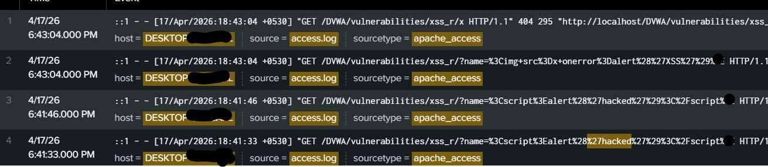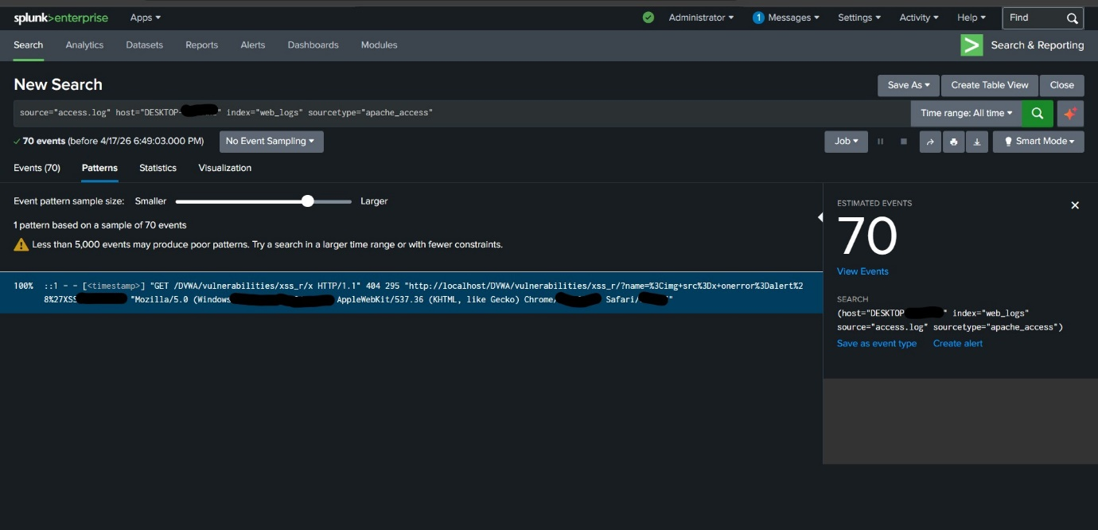

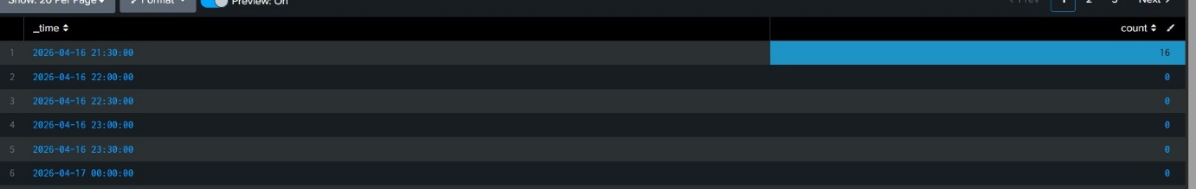

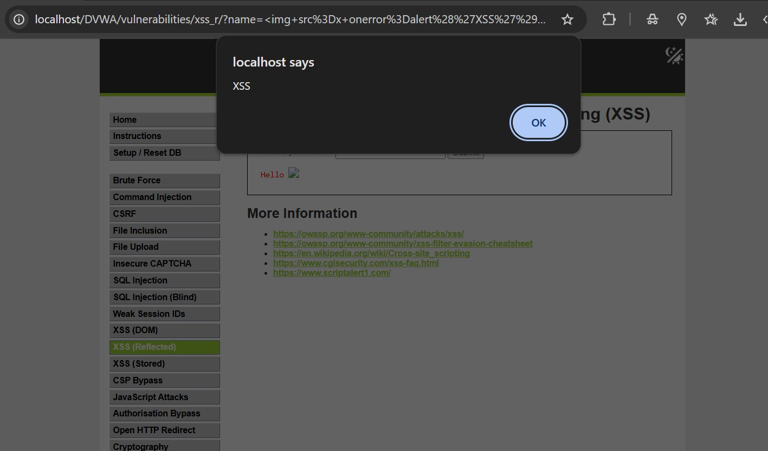

Detect Encoded Payload:
index=* "%3Cscript%3E" OR "%3Cimg"

Dashboard
Created a Splunk dashboard with:
- Top attacking IPs
- Attack trends over time
- HTTP status code distribution
- Attack URLs

Alerts Created
- XSS attack detection alert
- Multiple attempts alert (threshold-based)
- Encoded payload detection alert

Key Learnings
- Understanding of XSS attack execution
- Log-based detection of web attacks
- Working with encoded payloads
- Real-world SOC investigation workflow

Conclusion
This project demonstrates practical skills in web attack detection and log analysis using Splunk, simulating real SOC analyst tasks.
XSS happens when a website does not properly validate or sanitize user input, allowing attackers to run scripts in the browser of victims.

